***TASK NO. 10:-*** ***Design automatic led Diwali lights (consisting of 6 led’s) such that it only works during night and can generate two patterns which can be toggled with switch. a. Pattern 1 – led blinks with a freq. of 500 msec. b. Pattern 2 – led blinks with a freq. of 1 sec.***

**Circuit Diagram:-**

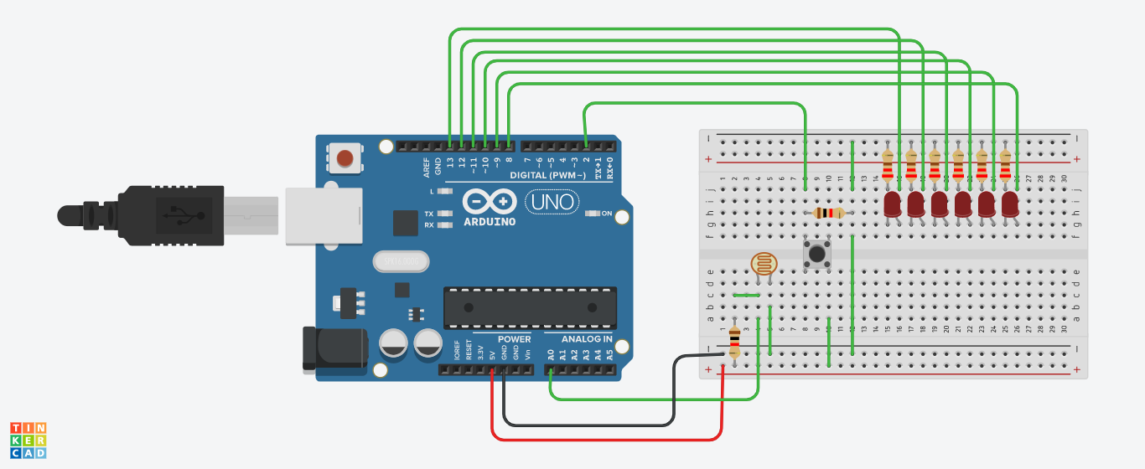

**Theory:**

**Concept Used:**

The concept used in realization of the circuit is that we first check whether it is day or night . If it is night (sensor value >600) then the leds glow . When switch is pressed, the leds blink with a frequency of 500ms( i.e the led glows again after a time period of 500ms) and when the switch is not pressed , the leds blink with a frequency of 1sec( i.e1000ms). The led patterns are toggled using a switch.

**Learning & Observations:**

I learned how to use LDR(Light Dependent Resistor) along with a switch and how the above problem can be solved. The observation was that at night the leds blink with 2 different patterns which can be toggled by a switch.

**Problems & Troubleshooting:**

The difficult part for me was the assembling of all the components on the breadboard to make the circuit work as asked. The other problem was with the positioning of the switch on tinkercad. The problem was solved after carefully analyzing the circuit.

**Precautions:**

* The wires and pins should be connected in the appropriate holes.
* The LED’s should be checked using a Multimeter before use.
* The wires should also be checked for continuity before use.
* The anode should be connected to the power supply and cathode to the ground.
* The LED should be connected to a resistor to prevent it from any damage.
* The switch should be carefully connected.

**Learning Outcomes:**

The learning which came from the above task was how to find an appropriate solution to a problem floated.